**How to connect Bluetooth Webcam**

1. Download **SmartCam_v1_4.exe** and **SmartCamAndroid_v1_4_0.apk** from:

[**http://sourceforge.net/projects/smartcam/files/smartcam_windows/SmartCam_v1_4/SmartCam_v1_4.exe/download**](http://sourceforge.net/projects/smartcam/files/smartcam_windows/SmartCam_v1_4/SmartCam_v1_4.exe/download)

and

**<http://sourceforge.net/projects/smartcam/files/smartcam_android/SmartCamAndroid_v1_4_0/SmartCamAndroid_v1_4_0.apk/download>**

1. Install **SmartCam_v1_4.exe** on your computer.
2. Install **SmartCamAndroid_v1_4_0.apk** on your Android mobile.
3. Start **SmartCam** on your computer. Then minimize it to the taskbar.

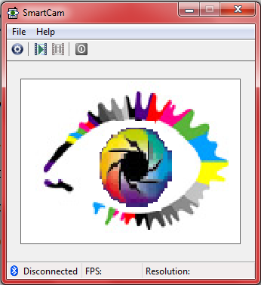

**Minimize it!**

1. Start **SmartCam** on your Android mobile.

Goto **Settings>>Bluetooth server.**

Select your desired **bluetooth server**.

Select **Connect bluetooth**.

Type **1234** as device’s required PIN and select **OK**.

1. Now, on your computer, click on the **Bluetooth Devices notification icon** on taskbar.

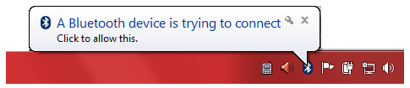

1. Type **1234** as device pairing code and select **Next**.

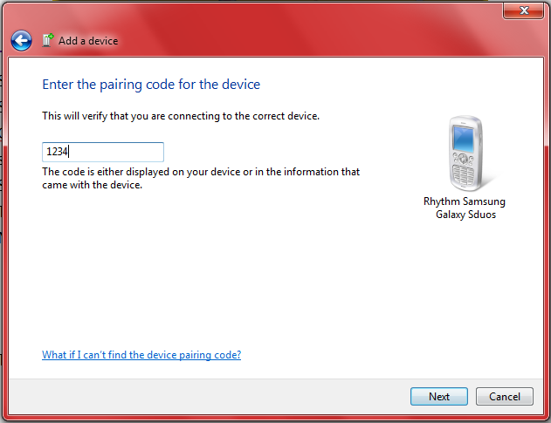

1. The device will be successfully added. Click on **Close**.

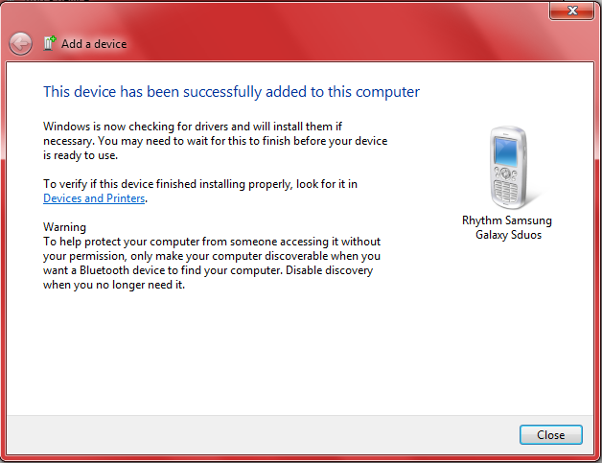

1. Finally, double click on the **SmartCam** icon on taskbar on your computer to maximize it. You’ll be able to see the video.



**Double click here to maximize.**

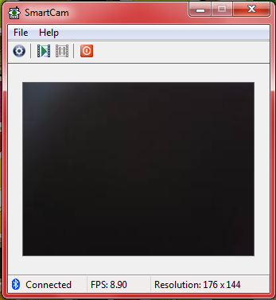

**Done !**